Project Report
Exploratory Analysis of Rainfall Data in India for Agriculture
Team Id: LTVIP2026TMIDS53672

1. INTRODUCTION
1.1 Project Overview
The Rainfall Prediction project aims to develop an intelligent weather forecasting system using Machine Learning techniques to predict whether it will rain tomorrow. Rainfall plays a critical role in agriculture, water resource management, disaster preparedness, and climate planning. Accurate rainfall prediction helps farmers plan irrigation schedules, assists governments in flood control, and improves overall environmental management.
This project utilizes historical weather data such as temperature, humidity, rainfall levels, wind speed, and atmospheric pressure to train classification models. The trained model is deployed using Flask to provide real-time rainfall prediction through a web interface.

1.2 Purpose
The purpose of the "Rainfall Prediction – Weather Forecasting using Machine Learning" project is to provide accurate and automated rainfall forecasting using data-driven approaches.
Traditional forecasting methods rely heavily on meteorological expertise and manual interpretation. This project leverages Machine Learning algorithms to analyze large volumes of historical weather data and identify hidden patterns that influence rainfall occurrence.
The main objectives include:
- Improving prediction accuracy
- Assisting farmers in crop planning
- Supporting disaster management authorities
- Enabling better water resource planning
- Providing a user-friendly web interface for prediction
The ultimate goal is to build a reliable and scalable rainfall prediction system that can assist decision-makers and the public.

2. IDEATION PHASE
2.1 Problem Statement
Rainfall prediction is complex due to the dynamic and non-linear behavior of weather conditions. Traditional statistical models often fail to capture complex relationships between weather parameters.
There is a need for an intelligent system that can:
- Analyze historical weather data
- Detect patterns and correlations
- Predict whether it will rain tomorrow
- Provide quick and reliable predictions through a web application

2.2 Empathy Map Canvas
Users:
- Farmers
- Agricultural Experts
- Disaster Management Authorities
- Meteorologists
What They Think & Feel:
- Need accurate rainfall predictions
- Want timely alerts
- Concerned about crop damage and floods
What They See:
- Changing climate conditions
- Unpredictable weather patterns
What They Say & Do:
- Check weather forecasts regularly
- Plan irrigation schedules
- Monitor weather alerts
Pain Points:
- Inaccurate predictions
- Sudden weather changes
Gains:
- Better crop yield
- Reduced disaster risks
- Efficient planning

2.3 Brainstorming
During brainstorming, multiple approaches were discussed:
- Using Regression vs Classification
- Comparing multiple ML models
- Deploying via Flask web application
- Handling imbalanced datasets using SMOTE
- Feature scaling and encoding techniques
Finally, classification-based ML models were selected.

3. REQUIREMENT ANALYSIS
3.1 Customer Journey Map
- User opens web application
- Enters weather parameters (temperature, humidity, etc.)
- Clicks Predict button
- Backend processes input
- Model predicts rainfall
- Result displayed (Chance / No Chance)

3.2 Solution Requirements
Functional Requirements:
- Accept weather input values
- Preprocess input data
- Predict rainfall using trained model
- Display prediction result
Non-Functional Requirements:
- High prediction accuracy
- Fast response time
- Scalable system
- User-friendly interface

3.3 Data Flow Diagram
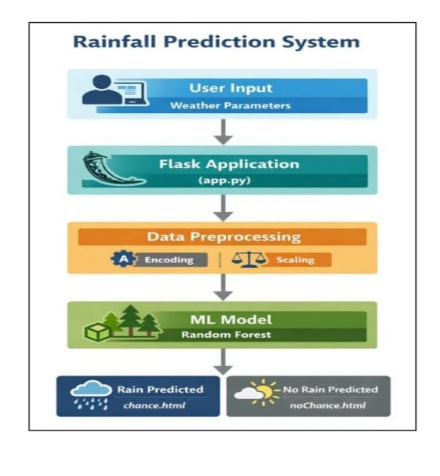
3.4 Technology Stack
- Python
- Pandas
- NumPy
- Scikit-learn
- XGBoost
- Flask
- HTML/CSS
- Matplotlib & Seaborn

4. PROJECT DESIGN
4.1 Problem Solution Fit
The rainfall prediction problem requires analyzing large historical datasets and detecting complex patterns. Machine Learning classification models provide a suitable solution to predict rainfall based on input features.

4.2 Proposed Solution
The proposed system:
- Collects historical weather data
- Performs preprocessing (null handling, encoding, scaling)
- Trains multiple ML models
- Compares performance
- Selects best model (XGBoost)
- Deploys model using Flask

4.3 Solution Architecture
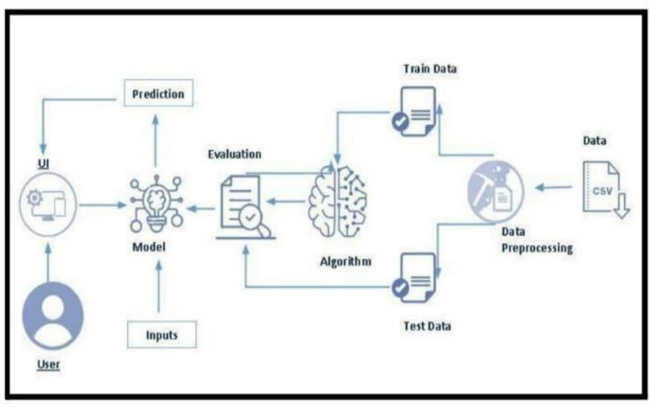
5. PROJECT PLANNING & SCHEDULING
5.1 Project Planning
The project was divided into 5 sprints:
- Sprint 1: Project Setup
- Sprint 2: Data Collection & Preprocessing
- Sprint 3: Model Development & Evaluation
- Sprint 4: Deployment
- Sprint 5: Testing & Optimization
Agile methodology was followed for systematic development.

6. FUNCTIONAL AND PERFORMANCE TESTING
6.1 Performance Testing
Models Tested:
- Decision Tree
- Random Forest
- Logistic Regression
- SVM
- Gradient Boosting
- XGBoost
Best Performing Model: XGBoost
Training Accuracy: 84.9%
Testing Accuracy: 81.1%
Evaluation Metrics Used:
- Accuracy Score
- Confusion Matrix
- Classification Report
- Cross Validation

7. RESULTS
7.1 Output Screenshots
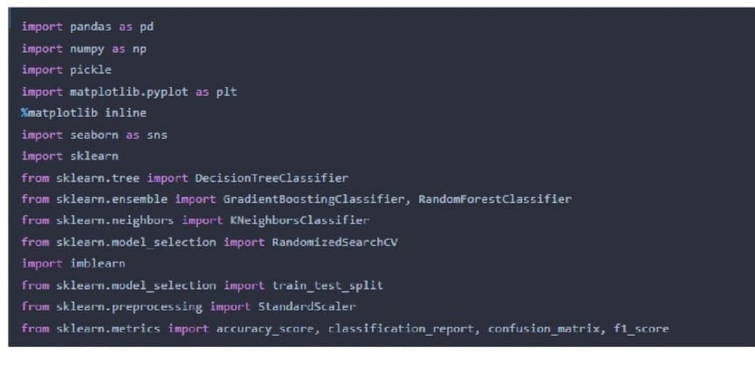

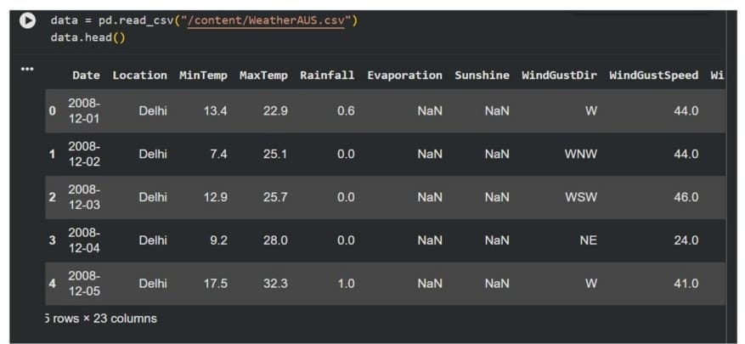

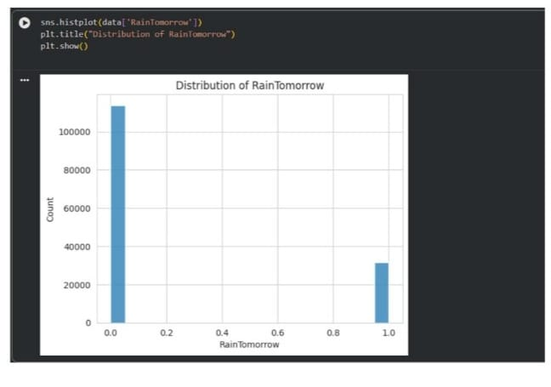
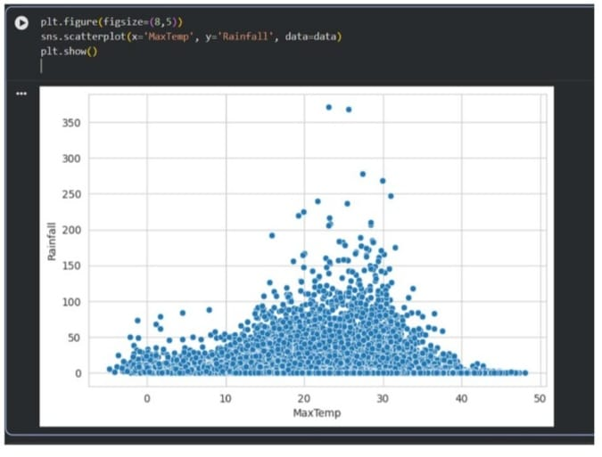
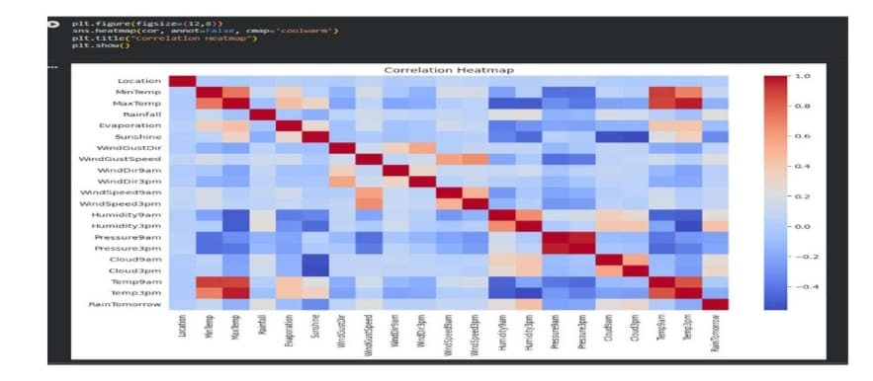
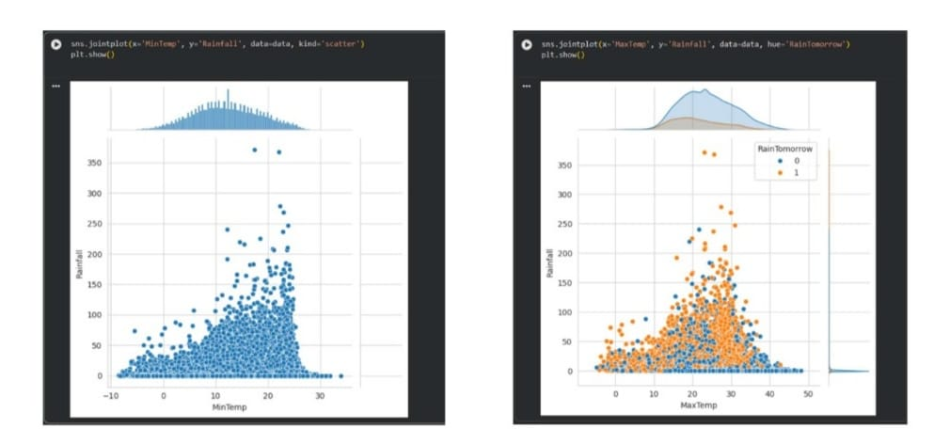
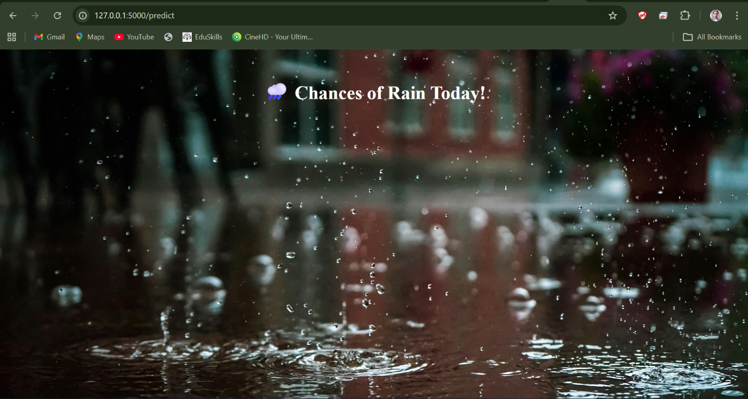
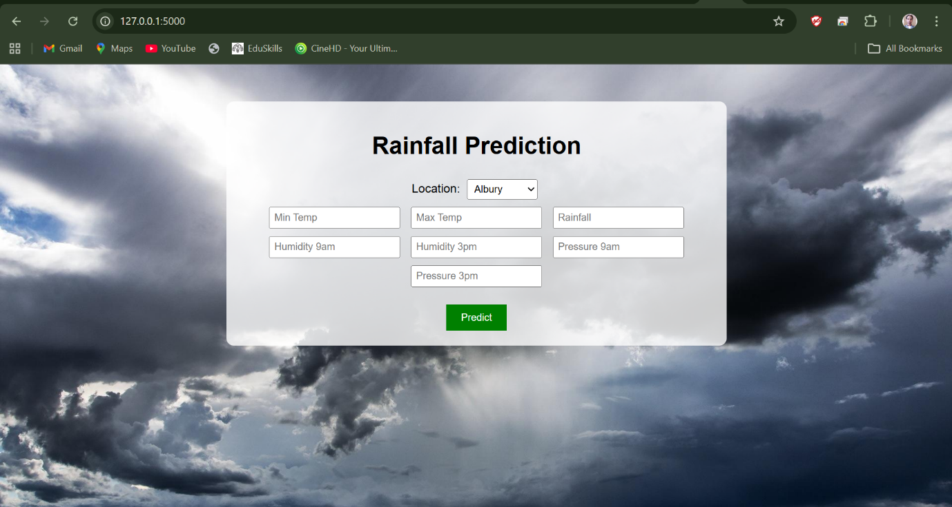
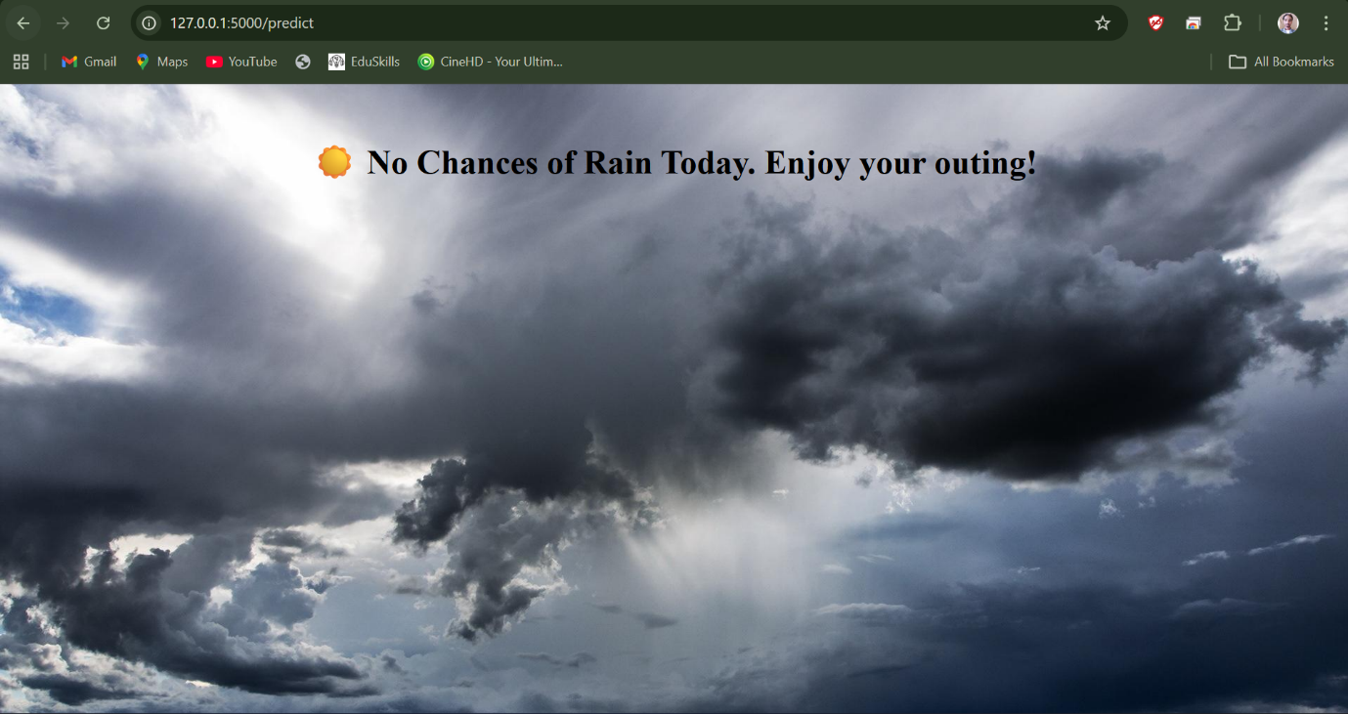

8. ADVANTAGES & DISADVANTAGES
Advantages
- Improved Accuracy
  - Machine learning models analyze large datasets and detect complex patterns.
- Automated Prediction
  - Eliminates manual forecasting dependency.
- Real-Time Prediction
  - Flask web application provides instant results.
- Scalability
  - Can be extended to regional or national weather systems.
- Agricultural Support
  - Helps farmers plan irrigation and crop management.

Disadvantages
- Data Dependency
  - Requires high-quality historical weather data.
- Model Complexity
  - Requires knowledge of machine learning concepts.
- Climate Variability
  - Sudden climate changes may affect prediction accuracy.
- Computational Resources
  - Training advanced models requires computational power.

9. CONCLUSION
In conclusion, the Rainfall Prediction project demonstrates the effective use of machine learning algorithms for weather forecasting. By analyzing historical weather data, the system successfully predicts whether it will rain tomorrow.
The integration of the model with a Flask web application makes the system user-friendly and accessible. With further improvements and additional data integration, the system can contribute significantly to agriculture and disaster management planning.

10. FUTURE SCOPE
Future improvements may include:
- Integration with real-time weather APIs
- Mobile application deployment
- Deep learning models (LSTM for time-series prediction)
- Regional weather forecasting
- Integration with smart agriculture systems
The system can evolve into a comprehensive weather intelligence platform.

11. APPENDIX
Complete Source Code Files:
- app.py
- rain.ipynb
- index.html
- chance.html
- nochance.html
- Weather.csv

